Configure Metrics Collection

Overview

This document provides a step-by-step guide to configuring metrics collection using Prometheus, custom exporters. It explains how to gather, scrape, and visualize system-level and application-specific metrics in a scalable and efficient way.
You will learn how to:

- Understand what metrics are and why they matter
- Set up Prometheus to scrape metrics from predefined and custom sources
- Create a custom Python exporter to expose application-specific metrics

Prerequisites
- System Requirements
  - A working Linux machine or VM (Ubuntu recommended)
  - Admin privileges or sudo access

- Tools Installed
  - Python 3.x
  - Flask installed via pip
  - pip3 install flask
  - Prometheus (running on port 9090)
  - Node Exporter (for system metrics, on port 9100)

Step 1: Start Prometheus

- Open Ubuntu terminal.

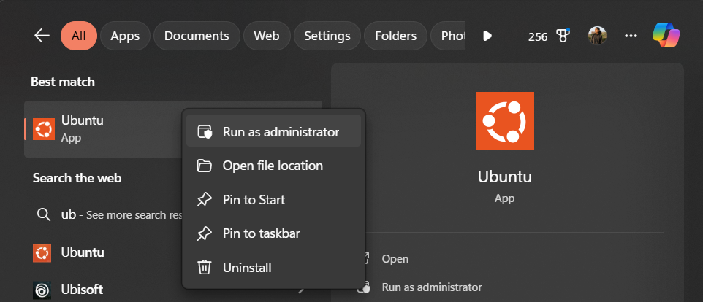

- Run the following command to start Prometheus:
  - sudo systemctl start prometheus

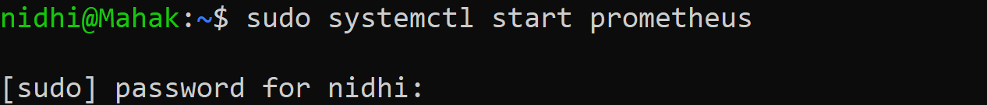
(enter your password)

- Open Prometheus in browser:
  - http://localhost:9090

What Are Metrics?

Metrics are numerical values representing system performance.

Examples include:

Metric | Meaning
CPU usage | How much CPU is being used
Memory usage | Amount of RAM consumed
Disk space | Storage used or available
Network traffic | Data sent/received
Uptime | How long system has been running
These metrics are exposed through exporters like:
- Node Exporter – for hardware & OS metrics (port 9100)
- Custom Exporters – built by you, like in Python!

Step 2: Confirm Prometheus is Scraping Metrics

- Open this in your browser:
  - http://localhost:9090/targets

You should see:

Target Status
localhost:9100 UP

If status is "UP", Prometheus is successfully collecting metrics from Node Exporter.
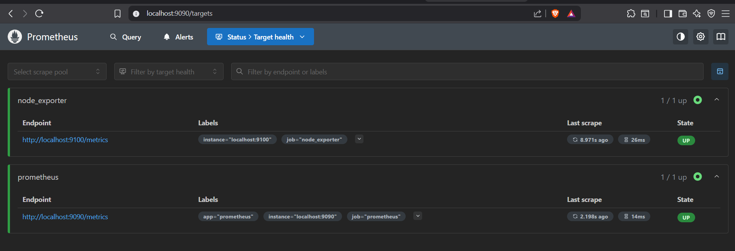

Step 3: Use Prometheus UI to Query Metrics

- Open Prometheus UI:
  - http://localhost:9090

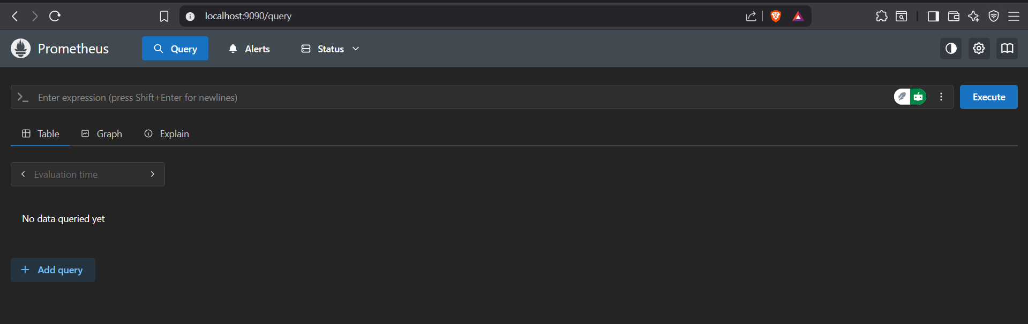

- Try querying a metric:
  - node_cpu_seconds_total

Click [Execute], and you'll see something like:
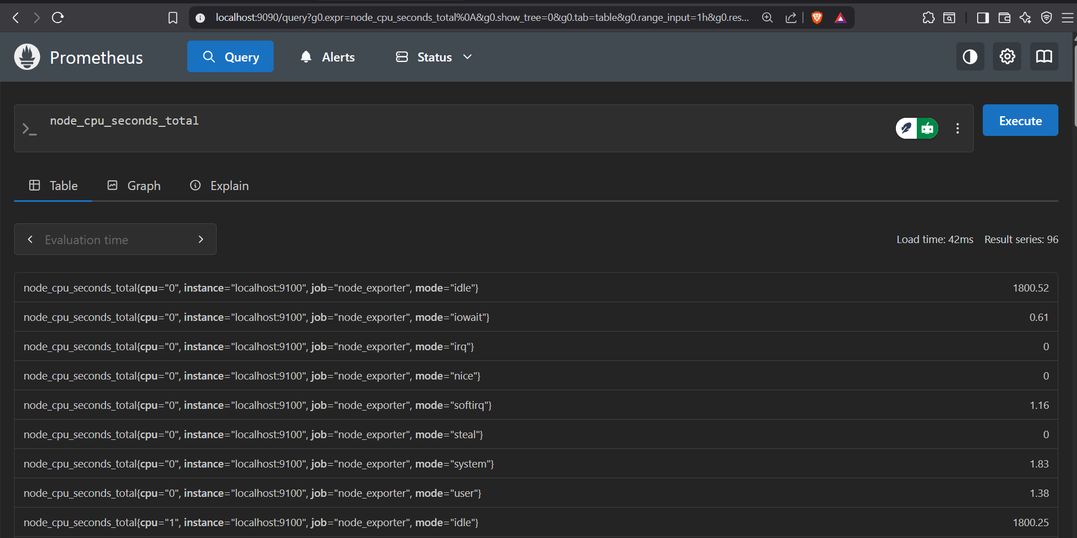

Common Prometheus metrics:

Metric Name Description
node_cpu_seconds_total CPU usage in different modes
node_memory_MemAvailable_bytes Available RAM
node_filesystem_avail_bytes Free space in file system
up Checks if target is UP (1 = yes)

Step 4: Add a New Metrics Source (Target)

- Open the ubuntu terminal
- Edit the Prometheus config file:
  - sudo nano /etc/prometheus/prometheus.yml

- Add another target:
scrape_configs:
- job_name: 'node_exporter'
static_configs:
- targets: ['localhost:9100', '172.30.203.92:9100']

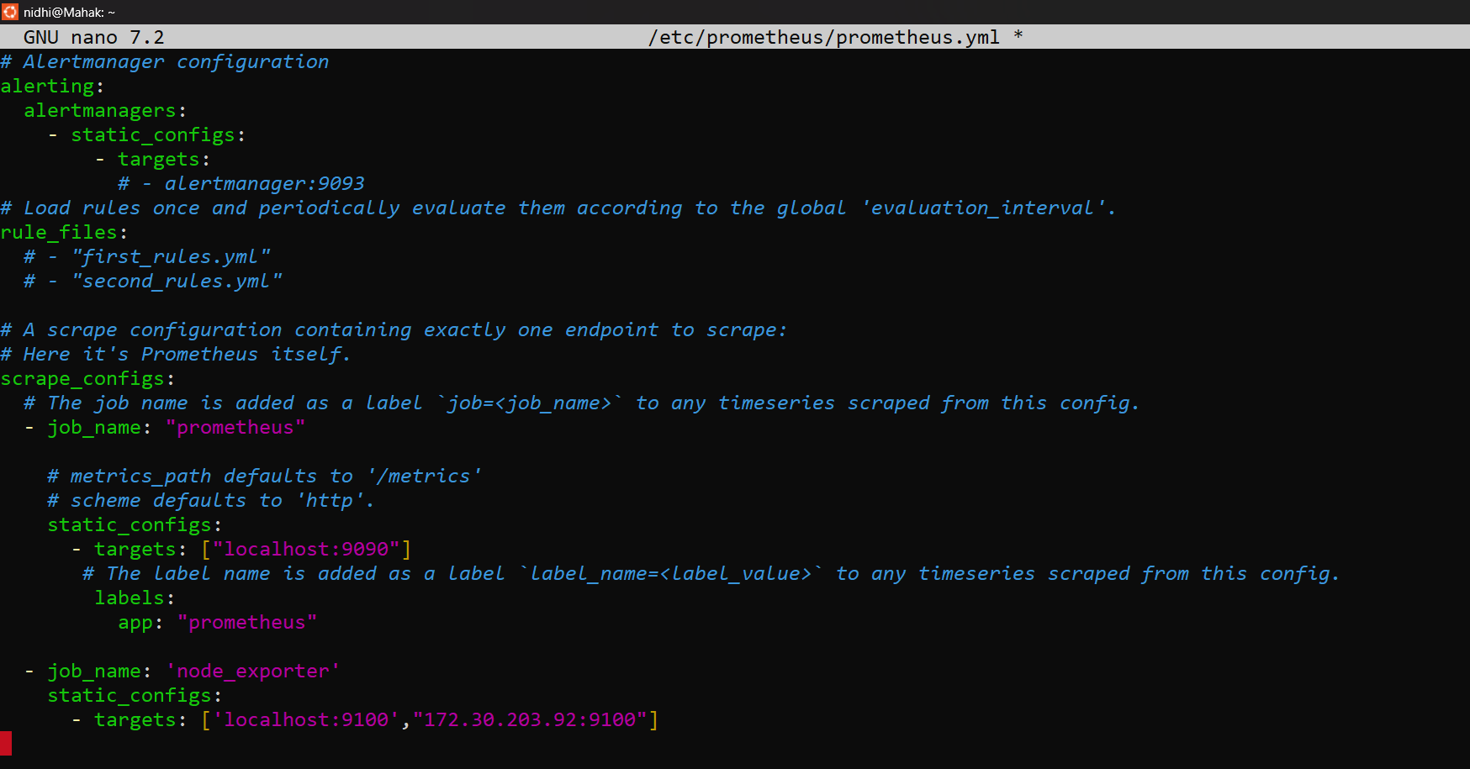

- Save and exit (Ctrl + O, Enter, Ctrl + X)

- Restart Prometheus:
  - sudo systemctl restart prometheus

Visit again:
http://localhost:9090/targets

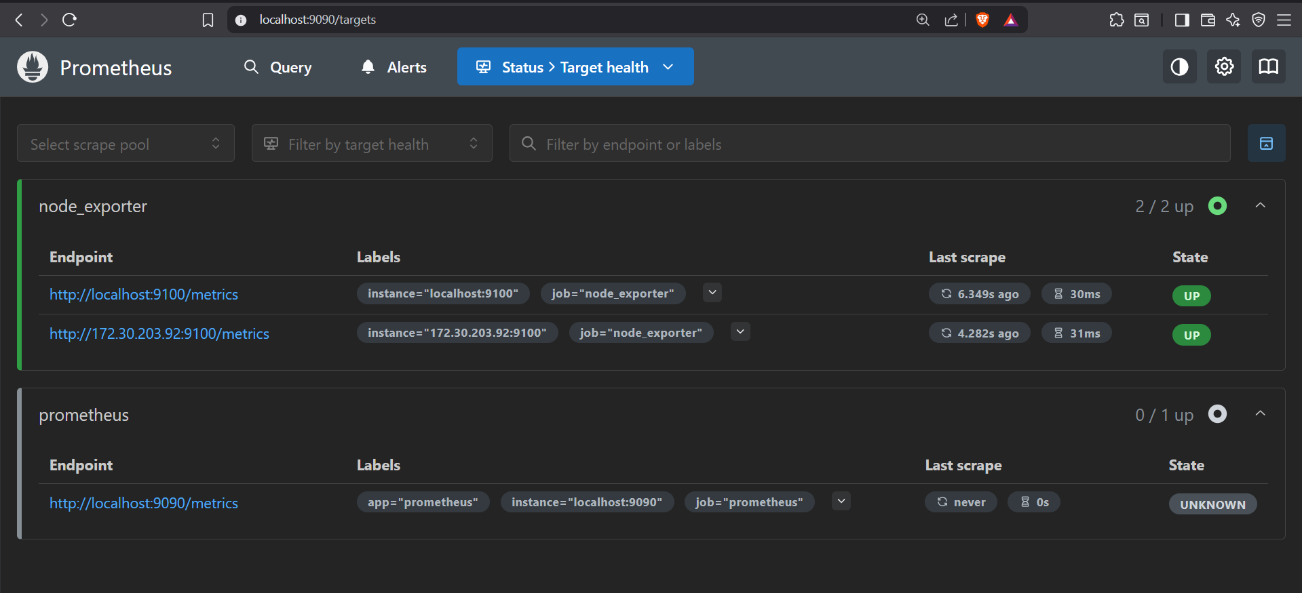

Now you’ll see multiple targets being scraped.

Step 5: Create a Custom Exporter (Python + Flask)

- Open Terminal in Your VM
You’ll do all the steps inside the same Ubuntu VM where Prometheus is running.

- Install Flask
If not already installed:
- sudo apt update
- sudo apt install python3-flask -y

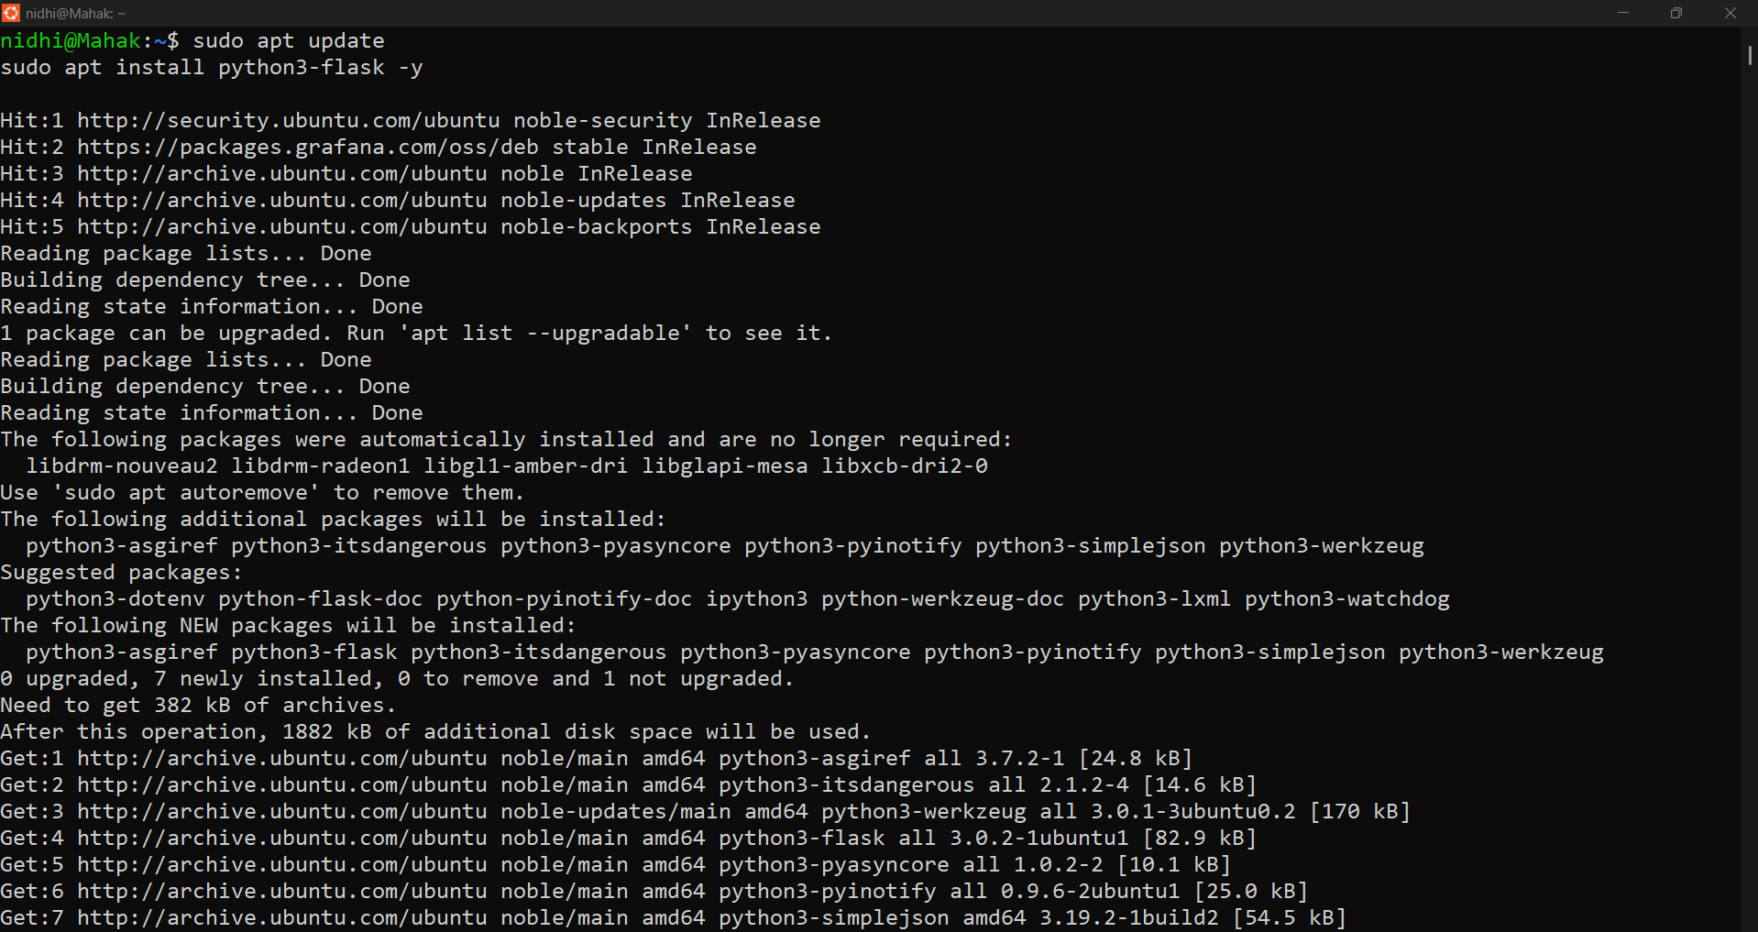

- Create Your Python Exporter Script
  - nano my_exporter.py

- Paste this code into it:

from flask import Flask, Response

app = Flask(__name__)

@app.route("/metrics")
def metrics():
data = "custom_metric_1 42\ncustom_metric_2 84"
return Response(data, mimetype='text/plain')

if __name__ == "__main__":
app.run(host="0.0.0.0", port=9000)

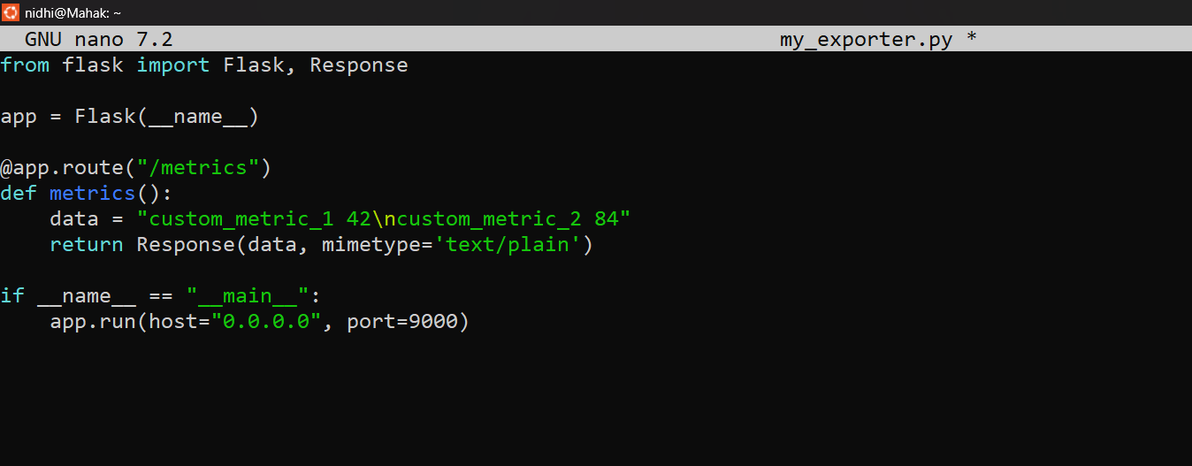

Press CTRL+O → Enter to save
Press CTRL+X to exit

- Run the Exporter
  - python3 my_exporter.py

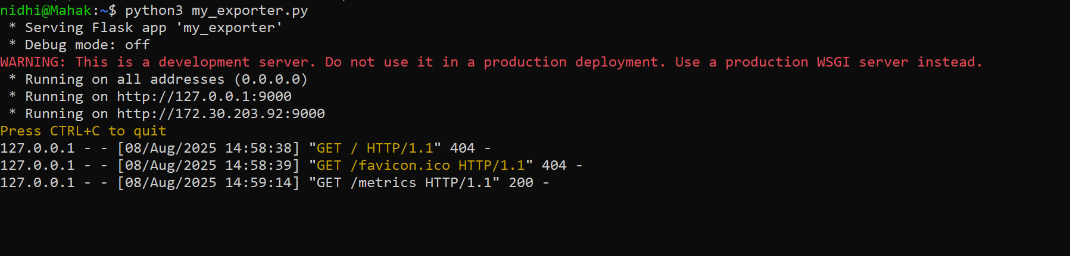

(Leave this terminal open — don’t press Ctrl+C.)

Now the custom exporter will start running on:
http://127.0.0.1:9000/metrics

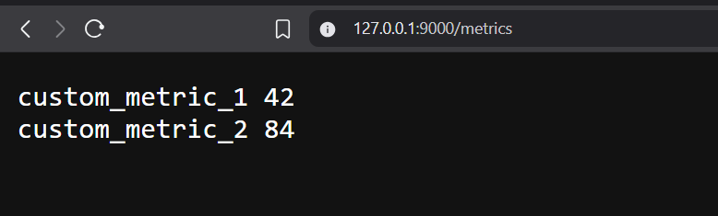

This is your custom metric endpoint!

Step 6: Add Custom Exporter to Prometheus

- Edit Prometheus config again:
  - sudo nano /etc/prometheus/prometheus.yml

- Add your new job:
- job_name: 'custom_python_exporter'
static_configs:
- targets: ['172.30.203.92:9000']

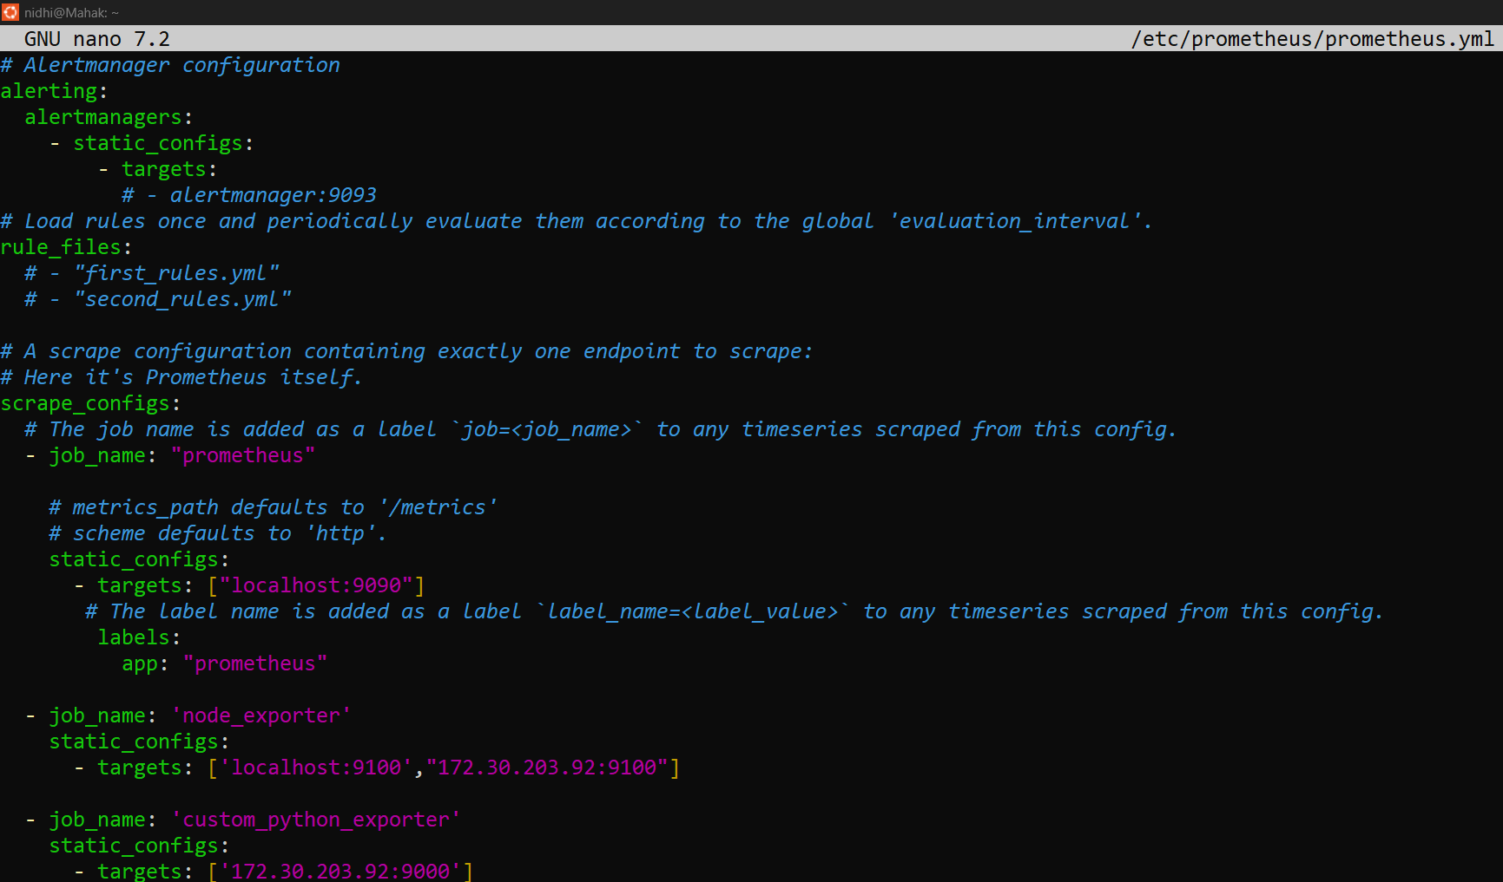

- Make sure it goes below the existing scrape_configs.

- Restart Prometheus:
  - sudo systemctl restart prometheus

Check targets:
http://localhost:9090/targets

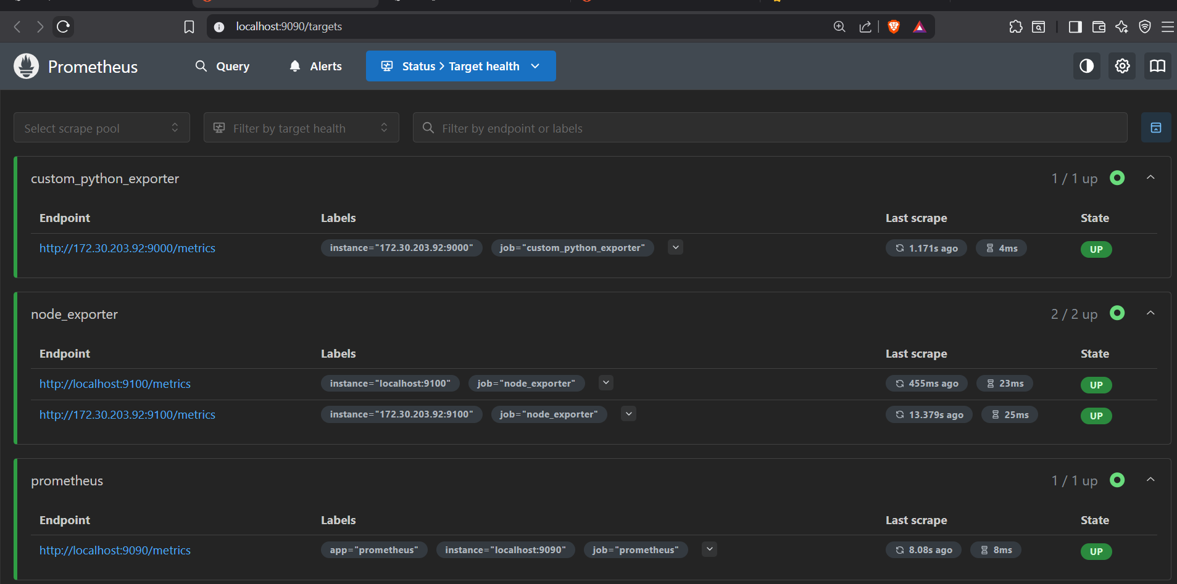

You should now see my_custom_exporter UP.

Go to http://localhost:9090/query

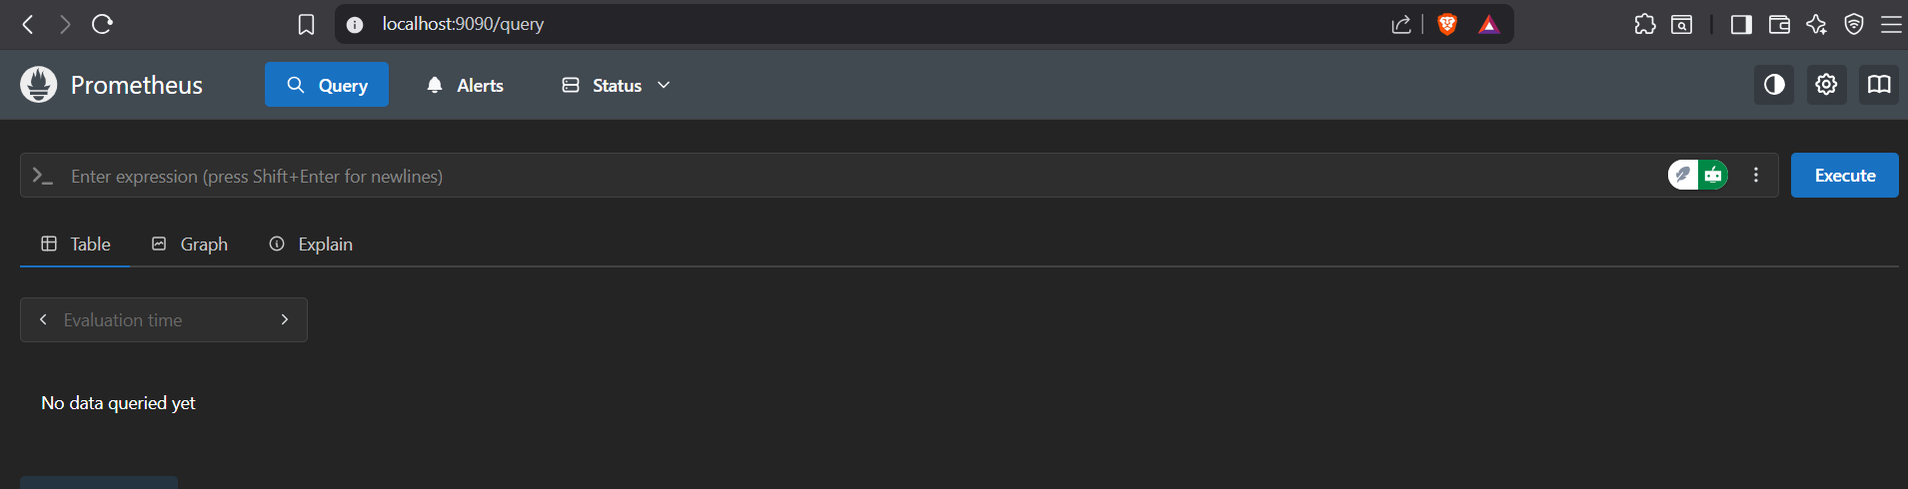

Search for your custom metric
- In the “Expression” box , type:
  - custom_metric_1
(You can also replace this with: custom_metric_2)
- Click "Execute"
This will run the query and show the result below the box.
You will see something like:

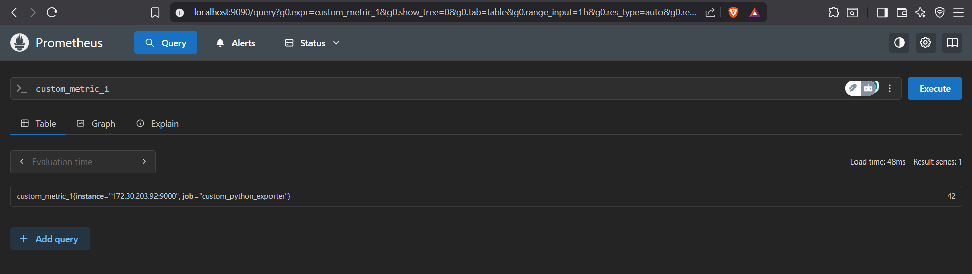

Your custom metric is now collected!

Conclusion

By following this guide, you have successfully configured a robust metrics collection system using Prometheus. You learned how to scrape system-level metrics using Node Exporter and build a custom Python exporter to expose application-specific metrics. With Prometheus properly set up and targets added, you can now query, monitor, and analyze performance data in real time. This foundation enables proactive system monitoring, faster debugging, and data-driven decision-making for your applications and infrastructure.

